Simulation of Engineering System 3 (ENG3036)
Assignment Report Template Part 2
Student Name: Gregor Johnston
Student Number: 2773209J
Assignment Topic: Position Control System for a Robotic Arm
2.0 Introduction for Part 2
After completing the first part of this assignment, it was concluded that the Position Control System for a Robotic Arm simulation created was flawed and needed improved. It was found to be highly underdamped, which meant it was very oscillatory, which I concluded was not ideal for a system that needs extremely high precision and accuracy.
Therefore, this report will be focused on improving the system. First the value of the coupler gain G_{c} will be changed to remove oscillation and decrease the time it takes to reach steady. Next an integral term will be added to the control system equation to eliminate steady state error and improve accuracy and stability. Finally, to make the system more realistic, using an interpolating polynomial the deflection of $θ_{U}$ will vary over time which will allow the simulated response of the forearm to be analysed during these changes.
Control System Design & Implementation
  - G_{c} Control Gain Variation Results & Analysis

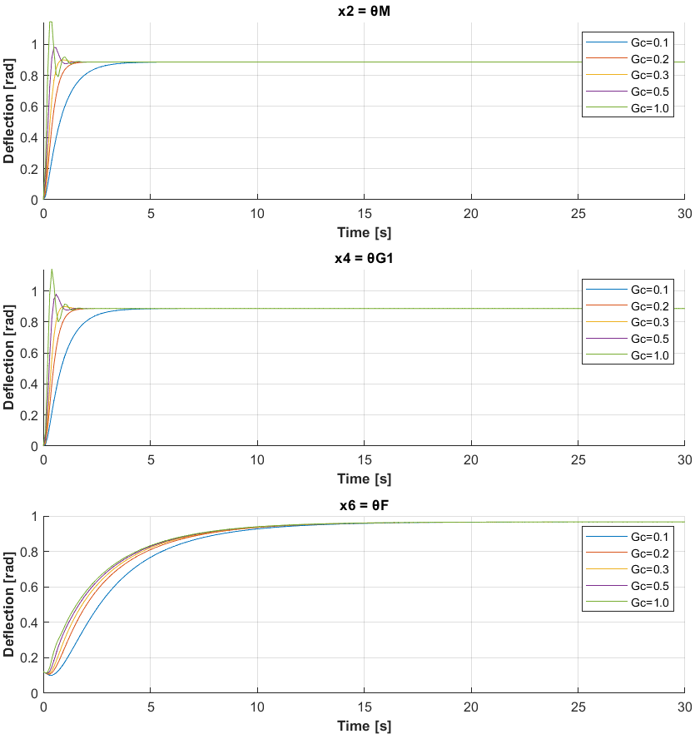
Figure 1: Effect on $θ_{M}$ deflection, $θ_{G1}$ deflection and $θ_{F}$ deflection when changing G_{c} value

Varying G_{c}​ influences the response speed, overshooting and steady-state accuracy. Lower G_{c} values result in slower responses and higher steady-state error because the control system applies weaker corrective actions to address deviations from the desired state, while higher G_{c}​ values lead to faster responses but cause increased overshooting or instability when too high, which can be seen in the above figure responses which are oscillatory when G_{c} is larger (i.e. when G_{c} = 1).

To find the optimal G_{c} value, the two most important characteristics are how fast does the simulated output reach steady state and how much is overshooting minimised. I have decided to go with G_{c} = 0.2, since it has the most optimal balance between minimising overshooting and reaching steady state quickly. G_{c} = 0.1 is not optimal since it reaches steady state slower than at 0.2 and G_{c} = 0.3 has very slight overshooting when compared with 0.2.

  - Integration Implementation in Control System in Matlab Code K_{I} Control Gain Variation Results & Analysis

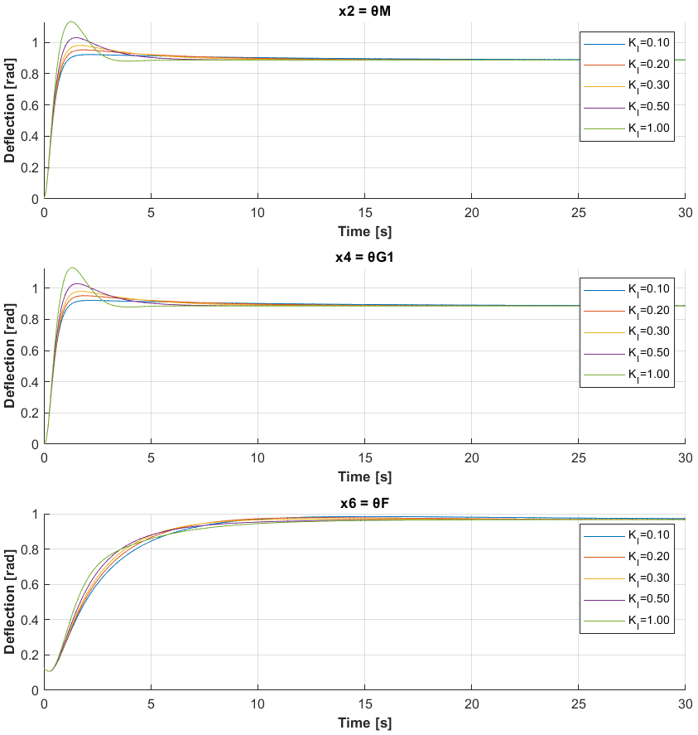
Figure 2: Effect on $θ_{M}$ deflection, $θ_{G1}$ deflection and $θ_{F}$ deflection when changing K_{I} value with G_{c} = 0.2

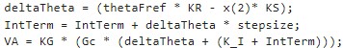
Figure 3: Integral implementation in MATLAB script

Changing the integral gain K_{I}​ improves the simulation output by addressing steady-state errors, which occur when the system fails to fully reach the desired target. The integral term accumulates the error over time and increases the corrective action proportionally, ensuring the system consistently moves toward eliminating the residual error and achieving better accuracy in the steady state. However, if K_{I} ​is too high, it can cause overshoot or instability due to excessive corrective action, which can be seen on the above figure (which is not unlike the oscillatory behaviour of increasing the G_{c} value). After testing a range of values, I found K_{I} = 0.1 to be the most optimal value, since it reached steady state quickly and did not overshoot or oscillate.
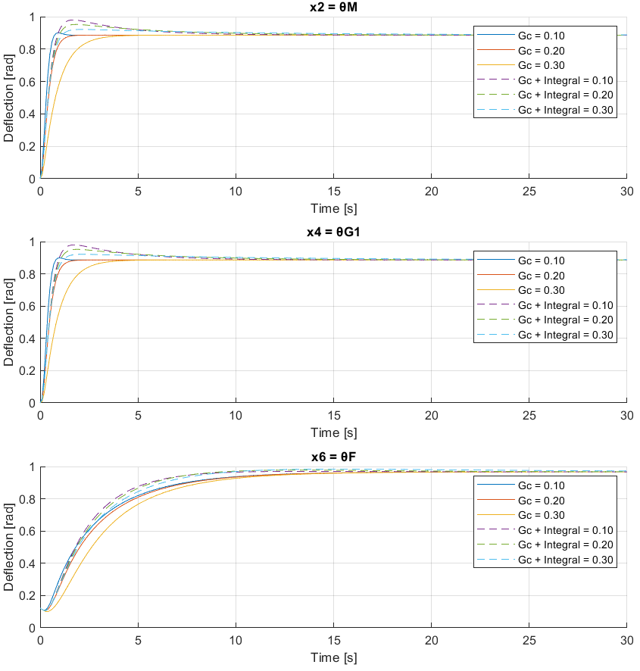
Figure 4: G_{c} (solid) vs G_{c} + Integral Term (dotted with G_{c} = 0.2 and changing K_{I})

When comparing the effect of adding the integral term to my chosen G_{c} value, it is clear from figure 4 that the integral term does not have much of an effect on the output simulation. These comparison results confirm that adding the integral term slightly decreases the amount of time it takes the simulation to get to steady state. Therefore, yes, the performance of this system IS improved further, but only marginally.
Interpolation
  - Interpolation Algorithm Calculation
Newtons Divided Difference Table
(Rounded to five decimal places for better readability, Rounded to nine decimal places in code)
Time (s) | $θ_{U}$ (°) | f[,] | f[,,] | f[,,,]
0 | 3 | f[t0,t1]  = $\frac{θ_{U1}-θ_{U0}}{t_{1}-t_{0}}$  =3
2.5 | 10.5 | f[t1,t2]  = $\frac{θ_{U2}-θ_{U1}}{t_{2}-t_{1}}$  =3.75 | f[t0,t1,t2]  = $\frac{f[t1,t2]-f[t0,t1]}{t_{2}-t_{0}}$  =0.11538 | f[t0,t1,t2,t3]  = $\frac{f[t1,t2,t3]-f[t0,t1,t2]}{t_{3}-t_{0}}$  = -0.02026
6.5 | 25.5 | f[t2,t3]  = $\frac{θ_{U3}-θ_{U2}}{t_{3}-t_{2}}$  =0.42857 | f[t1,t2,t3]  = $\frac{f[t2,t3]-f[t1,t2]}{t_{3}-t_{1}}$  = -0.22906 | f[t1,t2,t3,t4]  = $\frac{f[t2,t3,t4]-f[t1,t2,t3]}{t_{4}-t_{1}}$  = 0.01409
17 | 30 | f[t3,t4]  = $\frac{θ_{U4}-θ_{U3}}{t_{4}-t_{3}}$  = 1.27273 | f[t2,t3,t4]  = $\frac{f[t3,t4]-f[t2,t3]}{t_{4}-t_{2}}$  = 0.05276 | f[t2,t3,t4,t5]  = $\frac{f[t3,t4,t5]-f[t2,t3,t4]}{t_{5}-t_{2}}$  = 0.00254
22.5 | 37 | f[t4,t5]  = $\frac{θ_{U5}-θ_{U4}}{t_{5}-t_{4}}$  = 2.45455 | f[t3,t4,t5]  = $\frac{f[t4,t5]-f[t3,t4]}{t_{5}-t_{3}}$  = 0.10744
28 | 50.5

f[,,,,] | f[,,,,,]
f[t0,t1,t2,t3,t4]  = $\frac{f[t1,t2,t3,t4]-f[t0,t1,t2,t3]}{t_{4}-t_{0}}$  = 0.00153 | f[t0,t1,t2,t3,t4,t5]  = $\frac{f[t1,t2,t3,t4,t5]-f[t0,t1,t2,t3,t4]}{t_{5}-t_{0}}$  = -0.00007
f[t1,t2,t3,t4,t5]
= $\frac{f[t2,t3,t4,t5]-f[t1,t2,t3,t4]}{t_{5}-t_{1}}$
= -0.00045

Interpolating Polynomial:
$$P_{6}\left(t\right)=3+3\left(t-0\right)+0.11538\left(t-0\right)\left(t-2.5\right)-0.02026\left(t-0\right)\left(t-2.5\right)\left(t-6.5\right)+0.00153\left(t-0\right)\left(t-2.5\right)\left(t-6.5\right)\left(t-17\right)-0.00007\left(t-0\right)\left(t-2.5\right)\left(t-6.5\right)\left(t-17\right)\left(t-22.5\right) \{5dp\}$$

  - Interpolation MATLAB Code, Results & Analysis
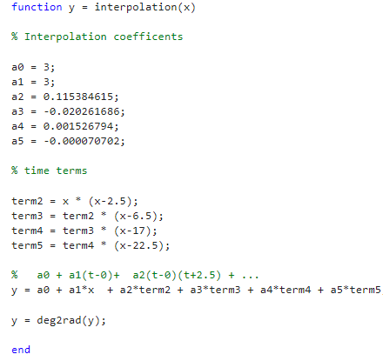
Figure 5: Interpolation polynomial implementation code
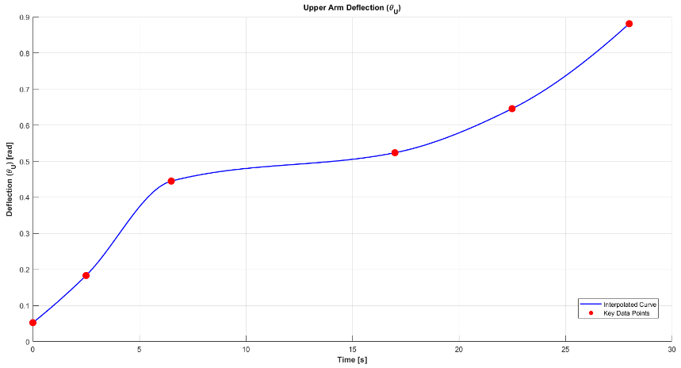
Figure 6: $θ_{U}$ simulation output with key points highlighted

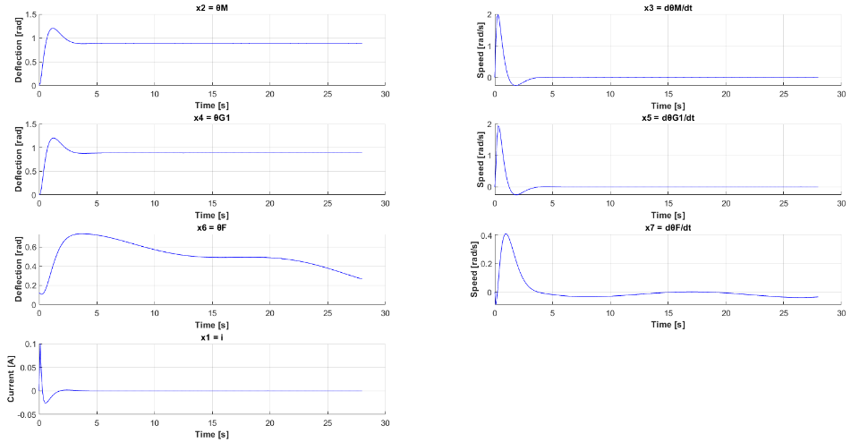
Figure 7: Simulation output with interpolation polynomial
When making changes to the $θ_{U}$ deflection over time using the interpolation polynomial the real-world dynamics of the system can be analysed instead of just analysing constants such as our previous constant deflection of 3°.
The upper arm starts at the original constant value of 3°, which means that the upper arm is initially pointed towards the ground, with a slight deflection forward (shoulder joint facing slightly upward). It then starts to move positively upward, speeding up and slowing down between the key data points, until the final deflection of 50.5° after 28 seconds, where the upper arm comes to a halt (as seen in figure 6). Since the upper arm deflection data finishes at 28 seconds, that is where the end time is set for the simulation. If we were to plot the full 30 seconds, results outside the scope of the deflection data would be plotted that would output unrealistic speeds and potentially incorrect simulations.
The forearm deflection outputs x₆ and x₇ can be seen reacting to these upper arm deflection changes. In figure 7 the deflection $θ_{F}$ can be seen moving to account for the changes in the upper arm. The forearm speed $\frac{dθ_{F}}{dt}$ can also be seen reacting, with a visible “bump” between 10 and 25 seconds. The reason the forearm speed cannot reach steady state is because the upper arm is constantly moving, therefore the forearm is also constantly moving to account for this so it can balance itself out.
  - Conclusions
The redesign of the robotic arm control system in Part 2 significantly improved the system's performance compared to Part 1. Adjusting the coupler gain G_{c} greatly reduced the oscillatory behaviour, striking a good balance between steady-state accuracy and response speed. Adding the integral gain K_{I}​ further enhanced the system’s stability by reducing steady-state error, albeit with marginal improvements.
Incorporating the interpolation polynomial for upper arm deflection $θ_{U}$​ introduced dynamic behaviour, providing a more realistic simulation of real-world conditions. Adding these redesign changes to the robotic arm system has greatly improved the overall performance of the simulation responses, with much less oscillations and much better steady state accuracy which has led to a much more reliable simulation.

